# Project – Database Foundation

Project Title: DBF 12

Tool – MySQL Workbench

DBF 12 - Technical Report

**Table of Contents**

1. Introduction
2. Requirements Definition Document
   1. Entity and Attribute Description
   2. Relationship, Cardinality Description and Business Rules
   3. Assumptions and Special Considerations
3. Detailed Database Design – Entity Relationship Diagram (ERD)
4. DDL Source Code
5. DML Source Code
6. Query Source Code
7. DDL Output
8. DML Output
9. Query Output

# Introduction

In this Database Design Document, we will see the design and implementation of a database for the front desk of our new hotel that has a theme park on the hotel premises itself. The Hotel is named as DBF 12 in loving memory of our database foundations class taught by Prof. Gasan Elkhodari. The Number 12 is derived from Group 12 that we are a part of and was generated by an auto-generator. As this document progresses, we will see the design and implementation of the database for the front desk of hotel DBF 12 that will store all the guest information with details, the rooms and the amenities they offer including the rates for it, reservation management system, pricing policies and finally computing total payment for our guests based on their selections, any discounts offered to them and storing the payment details. So, check out our new hotel DBF 12 that has its own theme park for your next vacation!

# Requirements Definition Document

* 1. **Entity and Attribute Description**

Entity Name: Guest

Entity Description: Guest is the primary entity around whom all the other entities would revolve. It includes details on all guests.

Main Attributes of Guest:

**Guest_ID:** (Primary Key) A unique identifier of the guest’s account in Hotel DBF 12’s database.

L_Name: Last Name of the guest who is the primary guest under whose name booking is made and who is responsible for clearing payment upon checkout

F_Name: First Name of the guest who is the primary guest under whose name booking is made and who is responsible for clearing payment upon checkout

Age: Age of the primary guest under whose name booking is made and who is responsible for clearing payment upon checkout. It is important to know the age as the hotel requires an adult to check-in. Also, the hotel offers a discount to senior citizens who are of the age 65 years and above.

Email_ID: Email_ID of the guest who is the primary guest under whose name booking is made and who is responsible for clearing payment upon checkout. Email_ID is used for the purposes of sending reservation confirmation, discount coupons and a copy of payment receipt.

Phone: It identifies the 10 digit phone number of the guest who is the primary guest under whose name booking is made and who is responsible for clearing payment upon checkout Platinum_Member: Identifier of whether a guest has a platinum membership at Hotel DBF 12 or not. It is identified as ‘Yes’ if the guest is a platinum member of Hotel DBF 12 and ‘No’ if the guest is not a platinum member of Hotel DBF 12.

Entity Name: Reservation

Entity Description: Reservation Entity reflects the reservation details of the guest like their planned stay at the hotel, purchase of theme park tickets and how far in advanced they made the reservation.

Main Attributes of Reservation:

**Res_No:** (Primary Key) A unique identifier of the guest’s reservation in Hotel DBF 12’s database.

Guest_ID: (Foreign Key) References the Guest table and connects each unique reservation to one guest.

Checkin_Dt: Date when the guest checks in at Hotel DBF 12. Checkout_Dt: Date when the guest checks out of Hotel DBF 12.

No_of_Nights: The total stay a guest is at the hotel for. It is computed through subtracting the Checkin_Dt from the Checkout_Dt

Res_Status: It reflects the status of the guest’s reservation. Whether the reservation is confirmed or is it in waiting status for a room to become available for the dates requested.

No_of_Guests : This is the total number of guests on a particular reservation that includes the primary guest who checked-in and all the other guests accompanying him/her.

No_of_TP_Tickets: It gives the count of DBF 12 theme park tickets a guest purchased along with their room reservation.

Res_Date: Date when the guest made the reservation. It is an important factor in deciding the discount for the guest. If the guest made the reservation 30 days before their check-in date, they would get an early bird discount of 10%.

Entity Name: Rooms

Entity Description: It describes the various features of a room that is reserved by a guest. Main Attributes of Rooms:

**Room_No:** (Primary Key) A unique identifier of each room. It is not auto generated but manually assigned by the Hotel Staff based on the attributes and amenities a customer selects while making reservations.

Res_No:(Foreign Key) References the Reservation table and connects each unique reservation to the room reserved under that reservation.

Room_Category: It categorizes a room into either Standard King, Standard Queen, Standard Twin or an Executive Suite.

Room_Type: It indicates whether a room is a smoking room or a non-smoking room Room_View: It indicates whether a room has a Pool View, Street View, Themepark View or a Garden View

Breakfast: It is a ‘Yes’ or ‘No’ indicator which indicates whether a buffet breakfast is included with the room reservation or not.

Room_Rate: It is a rate predetermined by the owner of the Hotel DBF 12 who has provided a specific non-changeable room rate card to the hotel front desk staff that is to be used for making any reservation and collection of final payment.

Entity Name: Pricing

Entity Description: Pricing table plays a crucial role in determining the final payment by indicating how much to charge each customer for their hotel stay and theme park tickets and what discounts to apply.

Main Attributes of Pricing:

**Pricing_ID:** (Primary Key) A unique identifier that indicates what price to charge based on the discounts a guest is eligible for. It follows the DBF 12 clause that only one type of discount can be offered to a guest even if they are eligible for more than one type of discount. The discount

with the maximum percentage off will be offered to the guest and the Pricing ID associated with that discount will be used to indicate the payment they should be charged.

Discount_Code: A unique identifier that identifies the discount offered to a guest. Discount_Type: It indicates the type of discount offered to a guest based on their eligibility. Discount_percent: It indicates the percentage off a guest would receive on their total bill based on their eligibility.

Theme_Park_Price: Kids under the age of 6 get a free theme park entry. A theme park entry ticket is required for anyone age of 6 and above who wishes to enjoy theme park rides and is sold at a flat rate of $55. A hotel guest is however not required to purchase the theme park ticket. It is their choice if they purchase the theme park ticket along with their stay at the hotel. If they purchase more than two theme park tickets, they get a discount of 5%. If they reserve a room and purchase a theme park ticket they get a discount of 20%. Again, as per DBF 12 clause, if a guest is eligible for more than one discount, only one discount would be applicable, whichever is higher.

Room_Tax_Rate: It indicates the total of city and state tax rate on hotel rooms which is 13% for Richardson where Hotel DBF 12 is located at. The only ones exempt from Room_Tax_Rate are guests with a state of Texas tax exempt certificate. In that event, the front desk would use the Pricing ID of 6 to indicate that they are Tax Exempt.

TP_Ticket_Tax_Rate: It indicates the sales tax of 8.25% to be charged on the purchase of each theme park ticket. The only ones exempt from TP_Ticket_Tax_Rate are guests with a state of Texas tax exempt certificate. In that event, the front desk would use the Pricing ID of 6 to indicate that they are Tax Exempt.

Entity Name: Payment

Entity Description: The Payment entity indicates the payment amount due for a guest for their stay at the hotel and purchase of theme park tickets and the payment details.

Main Attributes of Payment:

**Pmt ID:** (Primary Key) : A unique identifier that indicates the Payment ID associated with a particular reservation for a guest.

Res_No (Foreign Key): It references to the Reservation table and indicates the choices of the guest made under this reservation, the length of their stay and the number of theme park tickets purchased by them(if applicable).

Pricing_ID(Foreign Key): It references to the Pricing table. The Pricing ID is determined, based on the discount a guest is eligible for. It follows the DBF 12 clause that only one type of discount can be offered to a guest even if they are eligible for more than one type of discount. The discount with the maximum percentage off will be offered to the guest and the Pricing ID associated with that discount will be used to indicate the payment they should be charged.

Pmt_Method: It would indicate whether a guest would be using a credit card or a debit card for the payment of their hotel room stay and theme park ticket purchase if applicable.

Card_Number: A 16 digit number unique to each credit or debit card used to make the payment. Type_of_Card: It would indicate whether the card is a Visa or a Mastercard.

Name_on_Card: This would indicate the First name and Last name of the guest generated by concatenating the First Name and Last Name from the Guest Table

Exp_Date: This would indicate the expiration date of the credit or debit card used to make the payment by the guest.

Pmt_Status: This would indicate whether a guest who made a reservation at the hotel has paid in full and cleared their invoice or do they have a balance due. The balance due amount will be listed under the Final Payment Amount. The Final Payment Amount is subject to change based on the guest’s addition to additional theme park tickets or their extending the stay at the hotel.

Hence, the Final Payment Amount is calculated for the guest during the check-out process.

* 1. **Relationship, Cardinality Description and Business Rules** Relationship: has between GUEST and RESERVATION. Cardinality: 1:M between GUEST and RESERVATION.

Business rule: A GUEST may have zero, one or two RESERVATION at a given point in time; One RESERVATION must be associated with only one GUEST.

Relationship: shows between RESERVATION and ROOMS. Cardinality: 1:1 between RESERVATION and ROOMS.

Business rule: Each RESERVATION shows details on one ROOM associated with it. Each ROOM is associated with only one RESERVATION. Thus, only one ROOM can be booked per RESERVATION identified by a unique Reservation Number. If multiple ROOMS need to be booked, multiple RESERVATION under different Reservation Number should be made by the GUEST.

Relationship: associates between RESERVATION and PAYMENT. Cardinality: 1:1 between RESERVATION and PAYMENT.

Business rule: Each RESERVATION is associated with a unique PAYMENT. Each PAYMENT is associated with only one RESERVATION.

Relationship: determines between PRICING and PAYMENT. Cardinality: 1:1 between PRICING and PAYMENT.

Business rule: Each PRICING ID determines a unique PAYMENT. Each PAYMENT is associated with only one PRICING ID. This is possible through the hotel DBF 12 clause that only one Discount Code can be used at a time. If a guest is eligible for more than one type of Discount Code, the one with the higher percentage will be considered. Thus, their PAYMENT with only be determined by one PRICING ID that is associated with the higher discount code.

# BUSINESS RULES:

1. A GUEST may have zero, one or two RESERVATIONS at a given point in time
2. Each RESERVATION must be associated with only one GUEST.
3. Each RESERVATION shows details on one ROOM associated with it.
4. Each ROOM is associated with only one RESERVATION.
5. Each RESERVATION is associated with a unique PAYMENT.
6. Each PAYMENT is associated with only one RESERVATION.
7. Each PRICING ID determines a unique PAYMENT.
8. Each PAYMENT is associated with only one PRICING ID.

# Assumptions and Special Considerations

* + 1. Hotel DBF 12 clause is that only one Discount Code can be used at a time. If a guest is eligible for more than one type of Discount Code, the one with the higher percentage will be

considered. Thus, their PAYMENT will only be determined by one PRICING ID that is associated with the higher discount code.

* + 1. Kids under the age of 6 get a free theme park entry. A theme park entry ticket is required for anyone age of 6 and above and is sold at a flat rate of $55.
    2. Platinum Membership at DBF 12 is earned by accumulating points. When a Guest accumulates 1000 points, they are awarded platinum membership. Each stay at Hotel DBF 12 leads to accumulation of 100 points. Once a guest is a platinum member, they are eligible for the Platinum member discount of 15% and access to the Hotel’s VIP lounge on the Roof top. The Platinum Membership points and further details are maintained by our marketing staff in their database. The Guest table in the front desk database would only have an indication whether they are a platinum member or not.
    3. Guest records remain on DBF 12’s database for 3 years. After that they are purged. So, a guest who has been to the hotel in last three years will show up even if they don’t have a current reservation at the hotel. Also, DBF 12 accepts walk-ins, so we will let a guest check-in instantly without a prior reservation on record. Upon check-in, they will be assigned an auto-generated sequential Res No that will be associated with their account.
    4. Hotel DBF 12’s owner is very particular and has pre-determined the nightly rate for each room based on the Room Category, Type of Room, Type of View it Offers, whether it is a Smoking or Non-Smoking Room and whether a guest chooses to include Buffet Breakfast or Not as a part of their reservation. The Front Desk is expected to enter this amount for the Room Rate. The Owner has shared her Room Rate Card below:

|  |  |  |  |  |
| --- | --- | --- | --- | --- |
| Category | View | Type | Breakfast | Room Rate/night |
| Standard King | Street View | Non- Smoking | Yes | $170 |
| Standard King | Street View | Non- Smoking | No | $160 |
| Standard King | Street View | Smoking | Yes | $175 |
| Standard King | Street View | Smoking | No | $165 |
| Standard King | Themepark View | Non- Smoking | Yes | $185 |
| Standard King | Themepark View | Non- Smoking | No | $175 |
| Standard King | Themepark View | Smoking | Yes | $190 |
| Standard King | Themepark View | Smoking | No | $180 |
| Standard King | Pool View | Non- Smoking | Yes | $180 |

|  |  |  |  |  |
| --- | --- | --- | --- | --- |
| Standard King | Pool View | Non- Smoking | No | $170 |
| Standard King | Pool View | Smoking | Yes | $185 |
| Standard King | Pool View | Smoking | No | $175 |
| Standard King | Garden View | Non- Smoking | Yes | $175 |
| Standard King | Garden View | Non- Smoking | No | $165 |
| Standard King | Garden View | Smoking | Yes | $180 |
| Standard King | Garden View | Smoking | No | $170 |
| Standard Queen | Street View | Non- Smoking | Yes | $150 |
| Standard Queen | Street View | Non- Smoking | No | $140 |
| Standard Queen | Street View | Smoking | Yes | $155 |
| Standard Queen | Street View | Smoking | No | $145 |
| Standard Queen | Themepark View | Non- Smoking | Yes | $165 |
| Standard Queen | Themepark View | Non- Smoking | No | $155 |
| Standard Queen | Themepark View | Smoking | Yes | $170 |
| Standard Queen | Themepark View | Smoking | No | $160 |
| Standard Queen | Pool View | Non- Smoking | Yes | $160 |
| Standard Queen | Pool View | Non- Smoking | No | $150 |
| Standard Queen | Pool View | Smoking | Yes | $165 |
| Standard Queen | Pool View | Smoking | No | $155 |
| Standard Queen | Garden View | Non- Smoking | Yes | $155 |
| Standard Queen | Garden View | Non- Smoking | No | $145 |
| Standard Queen | Garden View | Smoking | Yes | $160 |
| Standard Queen | Garden View | Smoking | No | $150 |
| Standard Twin | Street View | Non- Smoking | Yes | $130 |
| Standard Twin | Street View | Non- Smoking | No | $120 |
| Standard Twin | Street View | Smoking | Yes | $135 |
| Standard Twin | Street View | Smoking | No | $125 |

|  |  |  |  |  |
| --- | --- | --- | --- | --- |
| Standard Twin | Themepark View | Non- Smoking | Yes | $145 |
| Standard Twin | Themepark View | Non- Smoking | No | $135 |
| Standard Twin | Themepark View | Smoking | Yes | $150 |
| Standard Twin | Themepark View | Smoking | No | $140 |
| Standard Twin | Pool View | Non- Smoking | Yes | $140 |
| Standard Twin | Pool View | Non- Smoking | No | $130 |
| Standard Twin | Pool View | Smoking | Yes | $145 |
| Standard Twin | Pool View | Smoking | No | $135 |
| Standard Twin | Garden View | Non- Smoking | Yes | $135 |
| Standard Twin | Garden View | Non- Smoking | No | $125 |
| Standard Twin | Garden View | Smoking | Yes | $140 |
| Standard Twin | Garden View | Smoking | No | $130 |
| Executive Suite | Street View | Non- Smoking | Yes | $210 |
| Executive Suite | Street View | Non- Smoking | No | $200 |
| Executive Suite | Street View | Smoking | Yes | $215 |
| Executive Suite | Street View | Smoking | No | $205 |
| Executive Suite | Themepark View | Non- Smoking | Yes | $225 |
| Executive Suite | Themepark View | Non- Smoking | No | $215 |
| Executive Suite | Themepark View | Smoking | Yes | $230 |
| Executive Suite | Themepark View | Smoking | No | $220 |
| Executive Suite | Pool View | Non- Smoking | Yes | $220 |
| Executive Suite | Pool View | Non- Smoking | No | $210 |
| Executive Suite | Pool View | Smoking | Yes | $225 |
| Executive Suite | Pool View | Smoking | No | $215 |
| Executive Suite | Garden View | Non- Smoking | Yes | $215 |

|  |  |  |  |  |
| --- | --- | --- | --- | --- |
| Executive Suite | Garden View | Non- Smoking | No | $205 |
| Executive Suite | Garden View | Smoking | Yes | $220 |
| Executive Suite | Garden View | Smoking | No | $210 |

# Detailed Database Design – Entity Relationship Diagram (ERD)

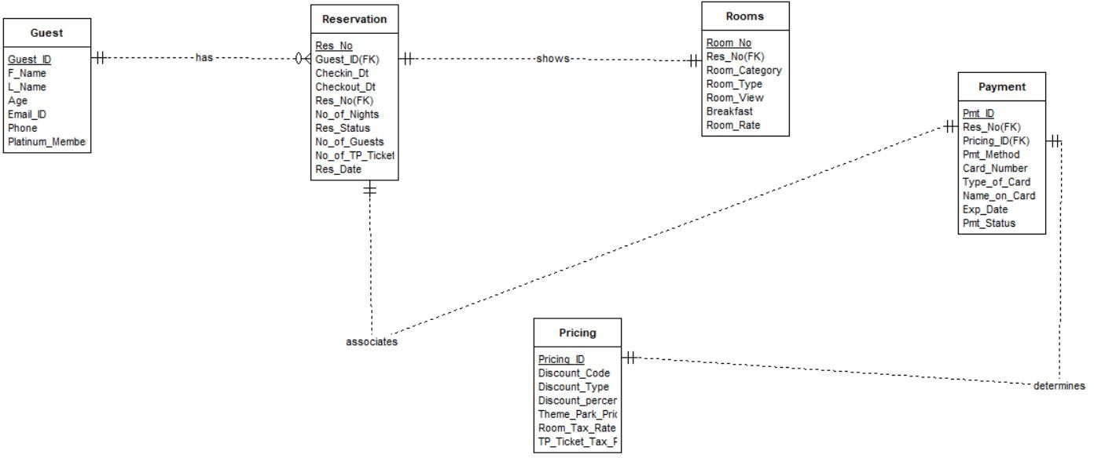

1. **DDL Source Code**

/*Project DBF 12- DDL*/

/* Create tables based on entities */

CREATE TABLE Guest

(

Guest_ID INTEGER AUTO_INCREMENT NOT NULL,

F_Name VARCHAR(25) NOT NULL,

L_Name VARCHAR(25) NOT NULL,

AGE INTEGER NOT NULL,

Email_ID VARCHAR(40) NOT NULL,

Phone VARCHAR(20) NOT NULL,

Platinum_Member VARCHAR(3) NOT NULL,

CONSTRAINT PK_Guest PRIMARY KEY (Guest_ID)

)AUTO_INCREMENT = 101;

CREATE TABLE Reservation

(

Res_no INTEGER AUTO_INCREMENT NOT NULL,

Guest_ID INTEGER NOT NULL,

Checkin_Dt DATE NOT NULL,

Checkout_Dt DATE NOT NULL,

No_of_Nights INTEGER GENERATED ALWAYS AS (DATEDIFF(Checkout_Dt, Checkin_Dt)) STORED,

Res_Status VARCHAR(50) NOT NULL,

No_of_Guests INTEGER NOT NULL,

No_of_TP_Tickets INTEGER NOT NULL,

Res_Date DATE NOT NULL,

CONSTRAINT PK_Reservation PRIMARY KEY (Res_no),

CONSTRAINT FK_Reservation FOREIGN KEY (Guest_ID) REFERENCES Guest(Guest_ID)

) AUTO_INCREMENT = 10025;

Create TABLE Rooms

(

Room_No INTEGER NOT NULL,

Res_No INTEGER NOT NULL,

Room_Category VARCHAR(30) NOT NULL,

Room_Type VARCHAR(30) NOT NULL,

Room_View VARCHAR(30) NOT NULL,

Breakfast VARCHAR(5) NOT NULL,

Room_Rate VARCHAR(15) NOT NULL,

CONSTRAINT PK_Rooms PRIMARY KEY (Room_No),

CONSTRAINT FK_Rooms FOREIGN KEY (Res_No) REFERENCES Reservation (Res_No)

);

CREATE TABLE Pricing

(

Pricing_ID INTEGER AUTO_INCREMENT NOT NULL,

Discount_Code VARCHAR(4) NOT NULL,

Discount_Type VARCHAR(35) NOT NULL,

Discount_percent INTEGER NOT NULL,

Theme_Park_Price INTEGER NOT NULL,

Room_Tax_Rate INTEGER NOT NULL,

TP_Ticket_Tax_Rate INTEGER NOT NULL,

CONSTRAINT PK_Pricing PRIMARY KEY (Pricing_ID)

)AUTO_INCREMENT = 1;

CREATE TABLE Payment

(

Pmt_ID INTEGER AUTO_INCREMENT NOT NULL,

Res_No INTEGER NOT NULL,

Pricing_ID INTEGER NOT NULL,

Pmt_Method VARCHAR(35) NOT NULL,

Card_Number VARCHAR(16) NOT NULL,

Type_of_Card VARCHAR(16) NOT NULL,

Name_on_Card VARCHAR(50) NOT NULL,

Exp_Date VARCHAR(7) NOT NULL,

Pmt_Status VARCHAR(20) NOT NULL,

CONSTRAINT PK_Payment PRIMARY KEY (Pmt_ID),

CONSTRAINT FK_Payment FOREIGN KEY (Res_No) REFERENCES Reservation (Res_No),

CONSTRAINT FK2_Payment FOREIGN KEY (Pricing_ID) REFERENCES Pricing (Pricing_ID)

)AUTO_INCREMENT = 130045;

/* Create indices for natural keys, foreign keys, and frequently-queried columns */

-- Guest

-- Natural keys

CREATE INDEX IDX_Guest_FName ON Guest (F_Name);

-- Frequently-queried columns

CREATE INDEX IDX_Guest_Age ON Guest (Age);

CREATE INDEX IDX_Guest_Platinum_Membership ON Guest (Platinum_Member);

-- Reservation

-- Frequently-queried columns

CREATE INDEX IDX_Reservation_No_of_Nights ON Reservation (No_of_Nights);

CREATE INDEX IDX_Reservation_No_of_TP_Tickets ON Reservation (No_of_TP_Tickets);

-- Foreign Key

CREATE INDEX IDX_Guest_ID ON Reservation (Guest_ID);

-- Rooms

-- Frequently-queried columns

CREATE INDEX IDX_Room_View ON Rooms (Room_View);

CREATE INDEX IDX_Room_Rate ON Rooms (Room_Rate);

-- Pricing

-- Frequently-queried columns

CREATE INDEX IDX_Pricing_Discount ON Pricing (Discount_percent);

CREATE INDEX IDX_Pricing_Discount_Type ON Pricing (Discount_Type);

-- Payment

-- Natural keys

CREATE INDEX IDX_Payment_Name_on_Card ON Payment (Name_on_Card);

-- Frequently-queried columns

CREATE INDEX IDX_Payment_Card_number ON Payment (Card_Number);

-- Foreign Keys

CREATE INDEX IDX_Payment_Res_No ON Payment (Res_No);

CREATE INDEX IDX_Paymnet_Pricing_ID ON Payment (Pricing_ID);

/* Alter Tables by adding Audit Columns */

ALTER TABLE Guest

ADD (

created_by VARCHAR(30), date_created DATE, modified_by VARCHAR(30), date_modified DATE

);

ALTER TABLE Reservation

ADD (

created_by VARCHAR(30), date_created DATE, modified_by VARCHAR(30), date_modified DATE

);

ALTER TABLE Rooms

ADD (

created_by VARCHAR(30), date_created DATE, modified_by VARCHAR(30), date_modified DATE

);

ALTER TABLE Pricing

ADD (

created_by VARCHAR(30), date_created DATE, modified_by VARCHAR(30), date_modified DATE

);

ALTER TABLE Payment

ADD (

created_by VARCHAR(30), date_created DATE, modified_by VARCHAR(30), date_modified DATE

);

/* Create Views */

-- Business purpose: The GuestInfo view will be used primarily for quickly searching information about individual guests for populating their Age and whether they are a Platinum member or not for computing discounts.

CREATE OR REPLACE VIEW GuestInfo AS

SELECT Guest_ID, F_Name, L_Name, Age, Platinum_Member

FROM Guest;

-- Business purpose: The ReservationInfo view will be used primarily for quickly searching information about individual guests for populating the number of theme park tickets they purchased and the number of nights they would be staying at the hotel to compute the payment amount for them

CREATE OR REPLACE VIEW ReservationInfo AS

SELECT Res_no, Guest_ID, No_of_Nights,No_of_TP_Tickets

FROM Reservation;

-- Business purpose: The RoomsInfo view will be used primarily for quickly searching about individual guests for populating the room type and room view and the price of the room

CREATE OR REPLACE VIEW RoomsInfo AS

SELECT Room_No, Room_Category, Room_Type, Room_View, Room_Rate

FROM Rooms;

-- Business purpose: The PricingInfo view will be used primarily for quickly searching information about the Discount Code and Discount Type to derive the Pricing_ID.

CREATE OR REPLACE VIEW PricingInfo AS

SELECT Pricing_ID, Discount_Type, Discount_percent

FROM Pricing;

-- Business purpose: The PaymentInfo view will be used primarily for quickly searching information about the name of card holder and respective Pmt_ID and Res_No associated with it.

CREATE OR REPLACE VIEW PaymentInfo AS

SELECT Pmt_ID, Res_No, Name_on_Card

FROM Payment;

/* Create Triggers */

-- Business purpose: The TR_Guest trigger automatically assigns a sequential Guest ID to a newly-inserted row in the Guest table, assigning appropriate values to the created_by and date_created fields. If the record is being inserted or updated, appropriate values are assigned to the modified_by and modified_date fields.

DELIMITER //

CREATE TRIGGER TR_Guest BEFORE INSERT ON Guest

FOR EACH ROW

BEGIN

IF NEW.Guest_ID IS NULL THEN

SET NEW.Guest_ID = (SELECT AUTO_INCREMENT FROM information_schema.TABLES WHERE TABLE_NAME = 'Guest' AND TABLE_SCHEMA = DATABASE()) + 1;

END IF;

IF NEW.created_by IS NULL THEN

SET NEW.created_by = USER();

END IF;

IF NEW.date_created IS NULL THEN

SET NEW.date_created = NOW();

END IF;

SET NEW.modified_by = USER();

SET NEW.date_modified = NOW();

END;

//

DELIMITER ;

-- Business purpose: The TR_Res trigger automatically assigns a sequential Reservation Number to a newly-inserted row in the Reservation table, assigning appropriate values to the created_by and date_created fields. If the record is being inserted or updated, appropriate values are assigned to the modified_by and modified_date fields.

DELIMITER //

CREATE TRIGGER TR_Res

BEFORE INSERT ON Reservation FOR EACH ROW

BEGIN

IF NEW.Res_No IS NULL THEN

SET NEW.Res_No = (SELECT NEXTVAL('SEQ_Res_No'));

END IF;

IF NEW.created_by IS NULL THEN

SET NEW.created_by = CURRENT_USER();

END IF;

IF NEW.date_created IS NULL THEN

SET NEW.date_created = NOW();

END IF;

SET NEW.modified_by = CURRENT_USER();

SET NEW.date_modified = NOW();

END;

//

DELIMITER ;

-- Business purpose: The TR_Rooms trigger automatically assigns appropriate values to the created_by and date_created fields. If the record is being inserted or updated, appropriate values are assigned to the modified_by and modified_date fields.

DELIMITER //

CREATE TRIGGER TR_Rooms

BEFORE INSERT ON Rooms FOR EACH ROW

BEGIN

IF NEW.created_by IS NULL THEN

SET NEW.created_by = CURRENT_USER();

END IF;

IF NEW.date_created IS NULL THEN

SET NEW.date_created = NOW();

END IF;

SET NEW.modified_by = CURRENT_USER();

SET NEW.date_modified = NOW();

END;

//

DELIMITER ;

-- Business purpose: The TR_Pricing trigger automatically assigns a sequential Pricing ID to a newly-inserted row in the Pricing table, assigning appropriate values to the created_by and date_created fields. If the record is being inserted or updated, appropriate values are assigned to the modified_by and modified_date fields.

DELIMITER //

CREATE TRIGGER TR_Pricing

BEFORE INSERT ON Pricing FOR EACH ROW

BEGIN

IF NEW.Pricing_ID IS NULL THEN

SET NEW.Pricing_ID = (SELECT NEXTVAL('SEQ_Pricing_ID'));

END IF;

IF NEW.created_by IS NULL THEN

SET NEW.created_by = CURRENT_USER();

END IF;

IF NEW.date_created IS NULL THEN

SET NEW.date_created = NOW();

END IF;

SET NEW.modified_by = CURRENT_USER();

SET NEW.date_modified = NOW();

END;

//

DELIMITER ;

-- Business purpose: The TR_Payment trigger automatically assigns a sequential Pmt ID to a newly-inserted row in the Payment table, assigning appropriate values to the created_by and date_created fields. If the record is being inserted or updated, appropriate values are assigned to the modified_by and modified_date fields.

DELIMITER //

CREATE TRIGGER TR_Payment

BEFORE INSERT ON Payment FOR EACH ROW

BEGIN

IF NEW.Pmt_ID IS NULL THEN

SET NEW.Pmt_ID = (SELECT NEXTVAL('SEQ_Pmt_ID'));

END IF;

IF NEW.created_by IS NULL THEN

SET NEW.created_by = CURRENT_USER();

END IF;

IF NEW.date_created IS NULL THEN

SET NEW.date_created = NOW();

END IF;

SET NEW.modified_by = CURRENT_USER();

SET NEW.date_modified = NOW();

END;

//

DELIMITER ;

/* Populate all tables */

-- Guest table

INSERT INTO Guest (F_Name, L_Name, Age, Email_ID, Phone, Platinum_Member)

VALUES ('Gasan', 'Elkhodari', 42, 'gasan.elkhodari@utdallas.edu', '(972)883-4779', 'Yes');

INSERT INTO Guest (F_Name, L_Name, Age, Email_ID, Phone, Platinum_Member)

VALUES ('Sai Suma', 'Maguluri', 24, 'saisuma.maguluri@utdallas.edu', '(972)883-2705', 'Yes');

INSERT INTO Guest (F_Name, L_Name, Age, Email_ID, Phone, Platinum_Member)

VALUES ('John', 'Doe', 69, 'john.doe@gmail.com', '(469)850-5189', 'No');

INSERT INTO Guest (F_Name, L_Name, Age, Email_ID, Phone, Platinum_Member)

VALUES ('Jacob', 'Foster', 31, 'jacob.foster@gmail.com', '(214)573-7890', 'Yes');

INSERT INTO Guest (F_Name, L_Name, Age, Email_ID, Phone, Platinum_Member)

VALUES ('John', 'Smith', 26,'john.smith@yahoo.com', '(469)650-9879', 'No');

INSERT INTO Guest (F_Name, L_Name, Age, Email_ID, Phone, Platinum_Member)

VALUES ('Andrea', 'Jones', 55, 'andreajones@hotmail.com', '(630)639-2914', 'No');

INSERT INTO Guest (F_Name, L_Name, Age, Email_ID, Phone, Platinum_Member)

VALUES ('Taylor', 'Anderson', 74,'taylor.anderson@gmail.com', '(469)879-0770', 'No');

INSERT INTO Guest (F_Name, L_Name, Age, Email_ID, Phone, Platinum_Member)

VALUES ('Aman', 'Sharma', 23,'sharmaaman@yahoo.com', '(847)245-0990', 'Yes');

INSERT INTO Guest (F_Name, L_Name, Age, Email_ID, Phone, Platinum_Member)

VALUES ('Kyle', 'Cunningham', 45,'cunninghamk@gmail.com', '(202)230-8970', 'Yes');

INSERT INTO Guest (F_Name, L_Name, Age, Email_ID, Phone, Platinum_Member)

VALUES ('Mehnaz', 'Mahmood', 51, 'mmahmood@yahoo.com', '(449)517-9809', 'No');

-- Reservation table

INSERT INTO Reservation (Guest_ID, Checkin_Dt, Checkout_Dt, Res_Status, No_of_Guests, No_of_TP_Tickets, Res_Date)

VALUES (101, '2022-10-24', '2022-10-27', 'Confirmed', 1, 0, '2022-10-14');

INSERT INTO Reservation (Guest_ID, Checkin_Dt, Checkout_Dt, Res_Status, No_of_Guests, No_of_TP_Tickets, Res_Date)

VALUES (102, '2022-09-29', '2022-10-03', 'Confirmed', 5, 5, '2022-09-10');

INSERT INTO Reservation (Guest_ID, Checkin_Dt, Checkout_Dt, Res_Status, No_of_Guests, No_of_TP_Tickets, Res_Date)

VALUES (103, '2022-10-21', '2022-10-26', 'Confirmed', 4, 4, '2022-10-11');

INSERT INTO Reservation (Guest_ID, Checkin_Dt, Checkout_Dt, Res_Status, No_of_Guests, No_of_TP_Tickets, Res_Date)

VALUES (104, '2022-11-14', '2022-11-19', 'Confirmed', 2, 2, '2022-10-30');

INSERT INTO Reservation (Guest_ID, Checkin_Dt, Checkout_Dt, Res_Status, No_of_Guests, No_of_TP_Tickets, Res_Date)

VALUES (105, '2022-11-27', '2022-12-01', 'Confirmed', 2, 2, '2022-11-20');

INSERT INTO Reservation (Guest_ID, Checkin_Dt, Checkout_Dt, Res_Status, No_of_Guests, No_of_TP_Tickets, Res_Date)

VALUES (106, '2022-12-08', '2022-12-12', 'Confirmed', 2, 2, '2022-11-15');

INSERT INTO Reservation (Guest_ID, Checkin_Dt, Checkout_Dt, Res_Status, No_of_Guests, No_of_TP_Tickets, Res_Date)

VALUES (107, '2022-12-12', '2022-12-15', 'Confirmed', 3, 2, '2022-11-10');

INSERT INTO Reservation (Guest_ID, Checkin_Dt, Checkout_Dt, Res_Status, No_of_Guests, No_of_TP_Tickets, Res_Date)

VALUES (108, '2022-12-15', '2022-12-18', 'Waiting_for_Room Availability', 4, 3, '2022-11-14');

INSERT INTO Reservation (Guest_ID, Checkin_Dt, Checkout_Dt, Res_Status, No_of_Guests, No_of_TP_Tickets, Res_Date)

VALUES (109, '2022-12-23', '2022-12-25', 'Waiting_for_Room Availability', 3, 3, '2022-11-22');

INSERT INTO Reservation (Guest_ID, Checkin_Dt, Checkout_Dt, Res_Status, No_of_Guests, No_of_TP_Tickets, Res_Date)

VALUES (110, '2022-12-25', '2022-12-30', 'Waiting_for_Room Availability', 2, 2, '2022-12-15');

-- Rooms Table

INSERT INTO Rooms (Room_No, Res_No, Room_Category, Room_Type, Room_View, Breakfast, Room_Rate)

VALUES ('401', '10025', 'Standard King', 'Non-Smoking', 'Street View', 'No', '$160');

INSERT INTO Rooms(Room_No, Res_No, Room_Category, Room_Type, Room_View, Breakfast, Room_Rate)

VALUES('302', '10026', 'Standard Queen', 'Smoking', 'Themepark View', 'Yes', '$170');

INSERT INTO Rooms(Room_No, Res_No, Room_Category, Room_Type, Room_View, Breakfast, Room_Rate)

VALUES('203', '10027', 'Standard Twin', 'Non-Smoking', 'Pool View', 'Yes', '$140');

INSERT INTO Rooms(Room_No, Res_No, Room_Category, Room_Type, Room_View, Breakfast, Room_Rate)

VALUES('504', '10028', 'Executive Suite', 'Smoking', 'Pool View', 'Yes', '$225');

INSERT INTO Rooms(Room_No, Res_No, Room_Category, Room_Type, Room_View, Breakfast, Room_Rate)

VALUES('305', '10029', 'Standard Queen', 'Smoking', 'Pool View', 'Yes', '$165');

INSERT INTO Rooms(Room_No, Res_No, Room_Category, Room_Type, Room_View, Breakfast, Room_Rate)

VALUES('206', '10030', 'Standard Twin', 'Non-Smoking', 'Themepark View', 'No', '$135');

INSERT INTO Rooms(Room_No, Res_No, Room_Category, Room_Type, Room_View, Breakfast, Room_Rate)

VALUES('507', '10031', 'Executive Suite', 'Smoking', 'Themepark View', 'Yes', '$230');

INSERT INTO Rooms(Room_No, Res_No, Room_Category, Room_Type, Room_View, Breakfast, Room_Rate)

VALUES('408', '10032', 'Standard King', 'Smoking', 'Garden View', 'Yes', '$180');

INSERT INTO Rooms(Room_No, Res_No, Room_Category, Room_Type, Room_View, Breakfast, Room_Rate)

VALUES('209', '10033', 'Standard Twin', 'Non-Smoking', 'Pool View', 'Yes', '$140');

INSERT INTO Rooms(Room_No, Res_No, Room_Category, Room_Type, Room_View, Breakfast, Room_Rate)

VALUES('510', '10034', 'Executive Suite', 'Smoking', 'Themepark View', 'Yes', '$230');

-- Pricing Table

INSERT INTO Pricing (Discount_Code, Discount_Type, Discount_percent, Theme_Park_Price, Room_Tax_Rate, TP_Ticket_Tax_Rate)

VALUES ('EB', 'Early Bird', 10, 55, 13, 8.25);

INSERT INTO Pricing (Discount_Code, Discount_Type, Discount_percent, Theme_Park_Price, Room_Tax_Rate, TP_Ticket_Tax_Rate)

VALUES ('RT', 'Room Theme Park Combo', 20, 55, 13, 8.25);

INSERT INTO Pricing (Discount_Code, Discount_Type, Discount_percent, Theme_Park_Price, Room_Tax_Rate, TP_Ticket_Tax_Rate)

VALUES ('SC', 'Senior Citizen Discount', 10, 55, 13, 8.25);

INSERT INTO Pricing (Discount_Code, Discount_Type, Discount_percent, Theme_Park_Price, Room_Tax_Rate, TP_Ticket_Tax_Rate)

VALUES ('PM', 'Platinum Member', 15, 55, 13, 8.25);

INSERT INTO Pricing (Discount_Code, Discount_Type, Discount_percent, Theme_Park_Price, Room_Tax_Rate, TP_Ticket_Tax_Rate)

VALUES ('T3', 'More than 2 Theme Park Tickets', 5, 55, 13, 8.25);

INSERT INTO Pricing (Discount_Code, Discount_Type, Discount_percent, Theme_Park_Price, Room_Tax_Rate, TP_Ticket_Tax_Rate)

VALUES ('EXEM', 'Tax Exempt', 0, 55, 0, 0);

INSERT INTO Pricing (Discount_Code, Discount_Type, Discount_percent, Theme_Park_Price, Room_Tax_Rate, TP_Ticket_Tax_Rate)

VALUES ('VET', 'Veteran', 7, 55, 13, 8.25);

INSERT INTO Pricing (Discount_Code, Discount_Type, Discount_percent, Theme_Park_Price, Room_Tax_Rate, TP_Ticket_Tax_Rate)

VALUES ('RES', 'Local Texas Resident', 2, 55, 13, 8.25);

INSERT INTO Pricing (Discount_Code, Discount_Type, Discount_percent, Theme_Park_Price, Room_Tax_Rate, TP_Ticket_Tax_Rate)

VALUES ('RSF', 'Room Service Food Order', 2, 55, 13, 8.25);

INSERT INTO Pricing (Discount_Code, Discount_Type, Discount_percent, Theme_Park_Price, Room_Tax_Rate, TP_Ticket_Tax_Rate)

VALUES ('CS', 'College Student', 3, 55, 13, 8.25);

-- Payment table

INSERT INTO Payment (Res_No, Pricing_ID, Pmt_Method, Card_Number, Type_of_Card, Name_on_Card, Exp_Date, Pmt_Status)

VALUES (10025,6,'Credit Card','4044120045673450','Visa','Gasan Elkhodari','04/2026','Paid');

INSERT INTO Payment (Res_No, Pricing_ID, Pmt_Method, Card_Number, Type_of_Card, Name_on_Card, Exp_Date, Pmt_Status)

VALUES (10026,2,'Debit Card','5002341245783458','Mastercard','Sai Suma Maguluri','05/2025','Paid');

INSERT INTO Payment (Res_No, Pricing_ID, Pmt_Method, Card_Number, Type_of_Card, Name_on_Card, Exp_Date, Pmt_Status)

VALUES (10027,2,'Credit Card','4232456789762345','Visa','John Doe','04/2023','Paid');

INSERT INTO Payment (Res_No, Pricing_ID, Pmt_Method, Card_Number, Type_of_Card, Name_on_Card, Exp_Date, Pmt_Status)

VALUES (10028,2,'Credit Card','4908789067534573','Visa','Jacob Foster','09/2026','Balance Due');

INSERT INTO Payment (Res_No, Pricing_ID, Pmt_Method, Card_Number, Type_of_Card, Name_on_Card, Exp_Date, Pmt_Status)

VALUES (10029,2,'Credit Card','5590898765456723','Mastercard','John Smith','07/2025','Balance Due');

INSERT INTO Payment (Res_No, Pricing_ID, Pmt_Method, Card_Number, Type_of_Card, Name_on_Card, Exp_Date, Pmt_Status)

VALUES (10030,2,'Credit Card','4890654323455789','Visa','Andrea Jones','12/2026','Balance Due');

INSERT INTO Payment (Res_No, Pricing_ID, Pmt_Method, Card_Number, Type_of_Card, Name_on_Card, Exp_Date, Pmt_Status)

VALUES (10031,2,'Credit Card','4509897654231257','Visa','Taylor Anderson','11/2025','Balance Due');

INSERT INTO Payment (Res_No, Pricing_ID, Pmt_Method, Card_Number, Type_of_Card, Name_on_Card, Exp_Date, Pmt_Status)

VALUES (10032,2,'Credit Card','4123578974562345','Visa','Aman Sharma','03/2024','Balance Due');

INSERT INTO Payment (Res_No, Pricing_ID, Pmt_Method, Card_Number, Type_of_Card, Name_on_Card, Exp_Date, Pmt_Status)

VALUES (10033,2,'Debit Card','4678657089234452','Visa','Kyle Cunningham','05/2024','Balance Due');

INSERT INTO Payment (Res_No, Pricing_ID, Pmt_Method, Card_Number, Type_of_Card, Name_on_Card, Exp_Date, Pmt_Status)

VALUES (10034,2,'Credit Card','5890786543218764','Mastercard','Mehnaz Mahmood','12/2023','Balance Due');

# Query Source Code

-- 20 SQL Queries

-- Q1. Select all columns and all rows from one table

SELECT * FROM Guest;

-- Q2. Select five columns and all rows from one table

SELECT Room_Category, Room_View, Room_Type, Breakfast, Room_Rate FROM Rooms;

-- Q3. Select all columns from all rows from one view

SELECT * FROM ReservationInfo;

-- Q4. Using a join on 2 tables, select all columns and all rows

SELECT * FROM Reservation

LEFT OUTER JOIN Guest ON Reservation.Guest_ID = Guest.Guest_ID;

-- Q5. Select and order data retrieved from one table

SELECT * FROM Rooms

ORDER BY Room_No;

-- Q6. Using a join on 3 tables, select 5 columns from the 3 tables. Use syntax that would limit the output to 10 rows

SELECT Guest.F_Name, Guest.L_Name, Reservation.Res_Status, Rooms.Room_Type, Rooms.Room_Rate

FROM Reservation

INNER JOIN Guest ON Reservation.Guest_ID = Guest.Guest_ID

INNER JOIN Rooms ON Rooms.Res_No = Reservation.Res_No

LIMIT 10;

-- Q7. Select distinct rows using joins on 3 tables

SELECT DISTINCT Rooms.Room_Category, Rooms.Room_View, Rooms.Room_Type, Rooms.Room_Rate, Payment.Pricing_ID

FROM Rooms

INNER JOIN Reservation ON Rooms.Res_no = Reservation.Res_no

INNER JOIN Payment ON Reservation.Res_no = Payment.Res_no;

-- Q8. Use GROUP BY and HAVING in a select statement using one or more tables

SELECT Room_Category, Room_View, Room_Type, Breakfast, Room_Rate

FROM Rooms

GROUP BY Room_Rate, Room_Category, Room_View, Room_Type, Breakfast

HAVING Room_View = 'Themepark View'

ORDER BY Room_Rate;

-- Q9.Use IN clause to select data from one or more tables

SELECT * FROM Pricing

WHERE Discount_percent IN (10,15,20);

-- Q10.Select length of one column from one table

SELECT L_Name, Length(L_Name) from Guest;

-- Q11.Delete one record from one table. Use select statements to demonstrate the table contents before and after the DELETE statement. Make sure you use ROLLBACK afterwards so that the data will not be physically removed

COMMIT;

SELECT * FROM Payment;

DELETE FROM Payment WHERE Pricing_ID = 6;

SELECT * FROM Payment;

ROLLBACK;

-- Q12.Update one record from one table. Use select statements to demonstrate the table contents before and after the UPDATE statement. Make sure you use ROLLBACK afterwards so that the data will not be physically removed

START TRANSACTION;

-- Your UPDATE statement

UPDATE Pricing

SET Discount_Type = 'Military Service Discount'

WHERE Pricing_ID = '7';

-- Optionally, you can SELECT to verify changes

SELECT * FROM Pricing WHERE Pricing_ID = '7';

SELECT * FROM Pricing;

-- If everything is correct, you can COMMIT the changes

COMMIT;

-- If there's an issue and you want to discard changes, you can ROLLBACK

ROLLBACK;

-- Q13. List all guests whose Reservation is in Confirmed Status. List their IDs, Reservation Number, First Name, Last Name, Room Number, Payment Status and Reservation Status

SELECT Guest.Guest_ID, Reservation.Res_No, Guest.F_Name, Guest.L_Name, Rooms.Room_No, Payment.Pmt_Status, Reservation.Res_Status

FROM Reservation

INNER JOIN Rooms ON Rooms.Res_No = Reservation.Res_No

INNER JOIN Guest ON Guest.Guest_ID = Reservation.Guest_ID

INNER JOIN Payment ON Reservation.Res_No = Payment.Res_No

WHERE Reservation.Res_Status = 'Confirmed';

-- Q14. Write a query to assist the front desk in order to prepare a list of all guests whose room rate is at least $180. The front desk would like to leave a small complimentary gift with a customized note in their room. Display their Room Number, First Name, Last Name, Room Rate, Payment Status

SELECT Rooms.Room_No, Guest.F_Name, Guest.L_Name, Rooms.Room_Rate, Payment.Pmt_Status from Rooms

INNER JOIN Reservation ON Rooms.Res_No = Reservation.Res_No

INNER JOIN Payment ON Reservation.Res_No = payment.Res_No

INNER JOIN Guest on Guest.Guest_ID = Reservation.Guest_ID

WHERE Rooms.Room_Rate >= '$180'

ORDER BY Rooms.Room_No;

-- Q15. Hotel DBF 12's Marketing Team reached out to get a list of most popular room categories that get booked the most. Write a query to assist the marketing team. List the Room Category and the Count of the Ones that get booked the most.

SELECT q1.Room_Category, q1.num_occurrences

FROM (

SELECT Rooms.Room_Category, COUNT(*) AS num_occurrences

FROM Rooms

GROUP BY Rooms.Room_Category

) q1, (

SELECT MAX(q2.num_occurrences) AS max_occurrences

FROM (

SELECT Rooms.Room_Category, COUNT(*) AS num_occurrences

FROM Rooms

GROUP BY Rooms.Room_Category

) q2

) q3

WHERE q1.num_occurrences = q3.max_occurrences;

-- Q16. List all reservations where the Room Theme Park Combo Discount has been applied and a Mastercard will be used for Payment

SELECT Reservation.Res_No, Guest.F_Name, Guest.L_Name, Reservation.Res_Status, Payment.Type_of_Card, Pricing.Discount_Code

FROM Guest

INNER JOIN Reservation ON Guest.Guest_ID = Reservation.Guest_ID

INNER JOIN Payment ON Reservation.Res_no = Payment.Res_No

INNER JOIN Pricing on Payment.Pricing_ID = Pricing.Pricing_ID

WHERE Payment.Type_Of_Card = 'Mastercard'

AND Pricing.Discount_Code = 'RT'

ORDER BY Res_No;

-- Q17. List all the platinum members who have made reservation for atleast 3 people and have purchased at least 2 Theme Park tickets

Select Guest.Guest_ID, Guest.F_Name, Guest.L_Name, Reservation.No_of_Guests, Reservation.No_of_TP_Tickets, Guest.Platinum_Member

FROM Guest

INNER JOIN Reservation ON Guest.Guest_ID = Reservation.Guest_ID

WHERE Guest.Platinum_Member = 'Yes'

AND Reservation.No_of_Guests >= 3

AND Reservation.No_of_TP_Tickets >= 2

ORDER BY Guest_ID;

-- Q18. Write a query to assist the front desk staff of DBF 12 to calculate room total, theme park total and final amt before and after discount for all the hotel guests.

CREATE TABLE payment_temp AS

SELECT

a.*,

(b.No_of_Nights) * CAST(SUBSTRING(c.Room_Rate, 2, 3) AS DECIMAL) AS room_total,

(b.No_of_TP_Tickets * d.Theme_Park_Price) AS Theme_park_total

FROM

payment a

LEFT OUTER JOIN reservation b ON a.RES_NO = b.RES_NO

LEFT OUTER JOIN rooms c ON b.RES_NO = c.RES_NO

LEFT OUTER JOIN pricing d ON a.pricing_id = d.pricing_id;

SELECT

a.PMT_ID,

a.RES_NO,

a.PRICING_ID,

a.ROOM_TOTAL,

a.THEME_PARK_TOTAL,

Room_Tax_Rate,

TP_Ticket_Tax_Rate,

(a.room_total * (1 + (b.Room_Tax_Rate / 100))) + (a.Theme_park_total * (1 + (b.TP_Ticket_Tax_Rate / 100))) AS final_amt_bef_disc,

((a.room_total * (1 + (b.Room_Tax_Rate / 100))) + (a.Theme_park_total * (1 + (b.TP_Ticket_Tax_Rate / 100)))) * (1 - (b.Discount_percent / 100)) AS final_amt_after_disc

FROM

payment_temp a

LEFT OUTER JOIN pricing b ON a.pricing_id = b.pricing_id;

-- Q19. One of the hotel guest Mr. Gasan Elkhodari showed up to the hotel front desk with a tax exempt certificate mentioning that the purpose of his stay at the hotel is for attending a conference nearby and as a state employee of University of Texas at Dallas, he should be exempted from taxes. Please write a query to assist the front desk staff for calculating Room total for Mr. Elkhodari and more guests like him in the future who would present a valid tax exempt certificate to the hotel front desk.

SELECT A.res_no, A.f_name, A.l_name, B.discount_code, A.room_rate, B.room_total

FROM (

SELECT *

FROM (

SELECT guest.guest_id AS g1_id, guest.f_name, guest.l_name

FROM guest

JOIN reservation ON guest.guest_id = reservation.guest_id

) AS A1,

(

SELECT reservation.guest_id AS g2_id, reservation.res_no, rooms.room_rate

FROM reservation

JOIN rooms ON reservation.res_no = rooms.res_no

) AS A2

WHERE A1.g1_id = A2.g2_id

) AS A,

(

SELECT T.res_no, pt.room_total, T.discount_code

FROM payment_temp AS pt,

(

SELECT pricing_id, res_no, discount_code

FROM (

SELECT res_no, discount_code, pricing_id

FROM pricing

JOIN (

SELECT reservation.res_no, pricing_id AS res_pid

FROM reservation, payment

WHERE reservation.res_no = payment.res_no

) AS P1 ON res_pid = pricing_id

) AS P2

WHERE discount_code = 'EXEM'

) AS T

WHERE pt.res_no = T.res_no

) AS B

WHERE A.res_no = B.res_no;

-- Q20. For people who availed Room theme park combo, find out how many platinum members are spending more than the average amount

create table payment_temp1 as

select a.*,Room_Tax_Rate,TP_Ticket_Tax_Rate,(a.room_total * (1+(b.Room_Tax_Rate/100)))+(a.Theme_park_total*(1+(b.TP_Ticket_Tax_Rate/100))) as final_amt_bef_disc,

((a.room_total * (1+(b.Room_Tax_Rate/100)))+(a.Theme_park_total*(1+(b.TP_Ticket_Tax_Rate/100))))*(1 - (b.Discount_percent/100)) as final_amt_after_disc

from payment_temp a left outer join pricing b

on a.pricing_id = b.pricing_id;

select a.platinum_member,count(a.guest_id) as COUNT_OF_CUSTOMERS_WHO_SPEND_ABOVE_AVERAGE

from guest a left outer join reservation b

on a.guest_id = b.guest_id

left outer join payment_temp1 c

on b.res_no = c.res_no

left outer join pricing d

on c.pricing_id = d.pricing_id

where d.discount_type = 'Room Theme Park Combo' AND

c.FINAL_AMT_AFTER_DISC > (select avg(FINAL_AMT_AFTER_DISC) from payment_temp1 where pricing_id in (select pricing_id from pricing where discount_type = 'Room Theme Park Combo'))

group by a.platinum_member;

DROP TABLE payment_temp;

DROP TABLE payment_temp1;

# DDL Output

Trigger TR_GUEST dropped. Trigger TR_RES dropped.

Trigger TR_ROOMS dropped. Trigger TR_PRICING dropped. Trigger TR_PAYMENT dropped. Sequence SEQ_GUEST_ID dropped. Sequence SEQ_RES_NO dropped.

Sequence SEQ_PRICING_ID dropped. Sequence SEQ_PMT_ID dropped.

View GUESTINFO dropped.

View RESERVATIONINFO dropped. View ROOMSINFO dropped.

View PRICINGINFO dropped. View PAYMENTINFO dropped.

Index IDX_GUEST_FNAME dropped. Index IDX_GUEST_AGE dropped.

Index IDX_GUEST_PLATINUM_MEMBERSHIP dropped. Index IDX_RESERVATION_NO_OF_NIGHTS dropped.

Index IDX_RESERVATION_NO_OF_TP_TICKETS dropped. Index IDX_ROOM_VIEW dropped.

Index IDX_ROOM_RATE dropped.

Index IDX_PRICING_DISCOUNT dropped.

Index IDX_PRICING_DISCOUNT_TYPE dropped. Index IDX_PAYMENT_NAME_ON_CARD dropped. Index IDX_PAYMENT_CARD_NUMBER dropped.

Index IDX_PAYMENT_RES_NO dropped. Index IDX_PAYMNET_PRICING_ID dropped. Table PAYMENT dropped.

Table PRICING dropped. Table ROOMS dropped.

Table RESERVATION dropped. Table GUEST dropped.

Table GUEST created.

Table RESERVATION created. Table ROOMS created.

Table PRICING created.

Table PAYMENT created.

Index IDX_GUEST_FNAME created. Index IDX_GUEST_AGE created.

Index IDX_GUEST_PLATINUM_MEMBERSHIP created. Index IDX_RESERVATION_NO_OF_NIGHTS created.

Index IDX_RESERVATION_NO_OF_TP_TICKETS created. Index IDX_GUEST_ID created.

Index IDX_ROOM_VIEW created. Index IDX_ROOM_RATE created.

Index IDX_PRICING_DISCOUNT created.

Index IDX_PRICING_DISCOUNT_TYPE created. Index IDX_PAYMENT_NAME_ON_CARD created. Index IDX_PAYMENT_CARD_NUMBER created. Index IDX_PAYMENT_RES_NO created.

Index IDX_PAYMNET_PRICING_ID created. Table GUEST altered.

Table RESERVATION altered. Table ROOMS altered.

Table PRICING altered.

Table PAYMENT altered.

View GUESTINFO created.

View RESERVATIONINFO created. View ROOMSINFO created.

View PRICINGINFO created. View PAYMENTINFO created.

Sequence SEQ_GUEST_ID created. Sequence SEQ_RES_NO created.

Sequence SEQ_PRICING_ID created. Sequence SEQ_PMT_ID created.

Trigger TR_GUEST compiled Trigger TR_RES compiled Trigger TR_ROOMS compiled Trigger TR_PRICING compiled Trigger TR_PAYMENT compiled

# DML Output

1 row inserted.

1 row inserted.

1 row inserted.

1 row inserted.

1 row inserted.

1 row inserted.

1 row inserted.

1 row inserted.

1 row inserted.

1 row inserted.

1 row inserted.

1 row inserted.

1 row inserted.

1 row inserted.

1 row inserted.

1 row inserted.

1 row inserted.

1 row inserted.

1 row inserted.

1 row inserted.

1 row inserted.

1 row inserted.

1 row inserted.

1 row inserted.

1 row inserted.

1 row inserted.

1 row inserted.

1 row inserted.

1 row inserted.

1 row inserted.

1 row inserted.

1 row inserted.

1 row inserted.

1 row inserted.

1 row inserted.

1 row inserted.

1 row inserted.

1 row inserted.

1 row inserted.

1 row inserted.

1 row inserted.

1 row inserted.

1 row inserted.

1 row inserted.

1 row inserted.

1 row inserted.

1 row inserted.

1 row inserted.

1 row inserted.

1 row inserted.

# Query Output

Q1:

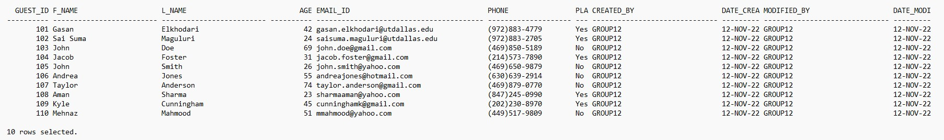

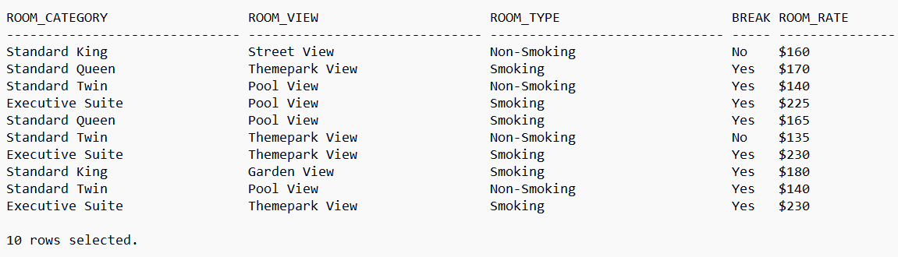Q2:

Q3:

RES_NO GUEST_ID NO_OF_NIGHTS NO_OF_TP_TICKETS

|  |  |  |  |
| --- | --- | --- | --- |
| 10025 | 101 | 3 | 0 |
| 10026 | 102 | 4 | 5 |
| 10027 | 103 | 5 | 4 |
| 10028 | 104 | 5 | 2 |
| 10029 | 105 | 4 | 2 |
| 10030 | 106 | 4 | 2 |
| 10031 | 107 | 3 | 2 |
| 10032 | 108 | 3 | 3 |
| 10033 | 109 | 2 | 3 |
| 10034 | 110 | 5 | 2 |

10 rows selected.

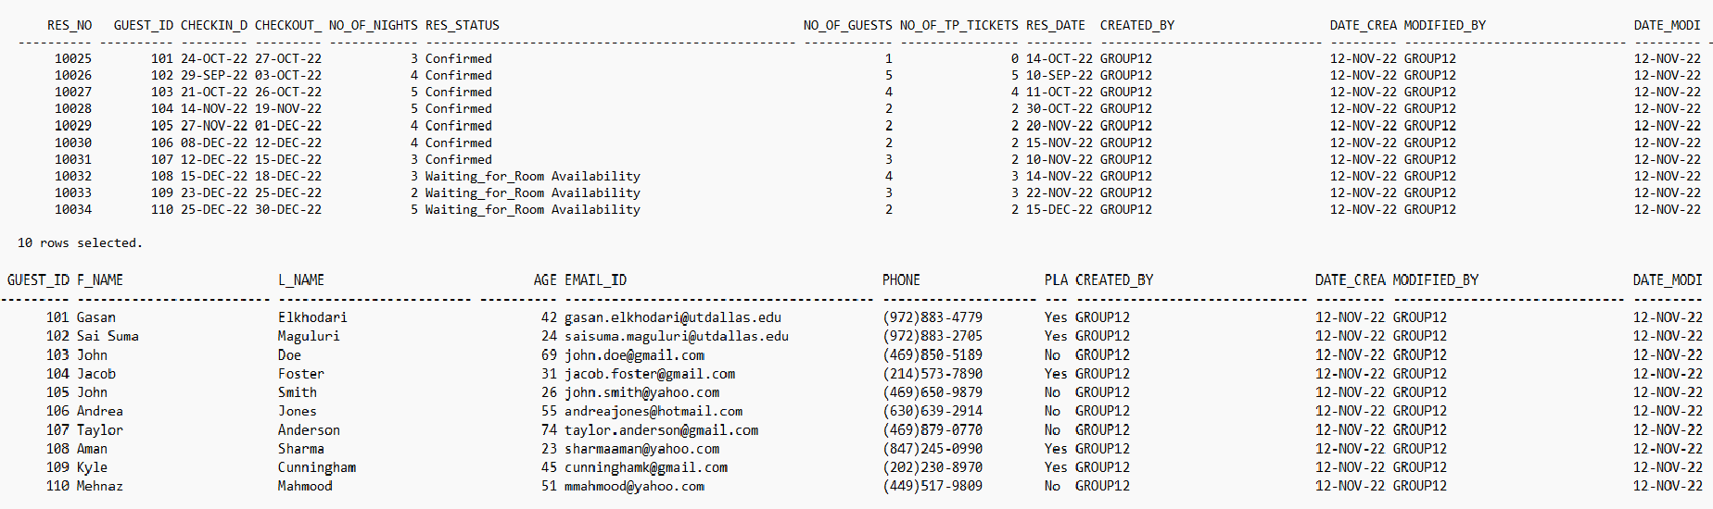Q4:

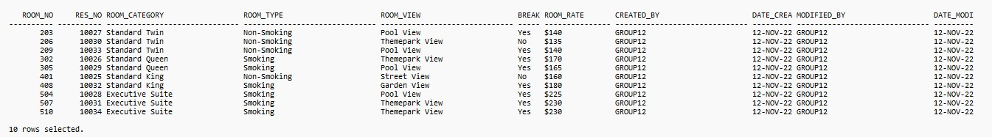Q5.

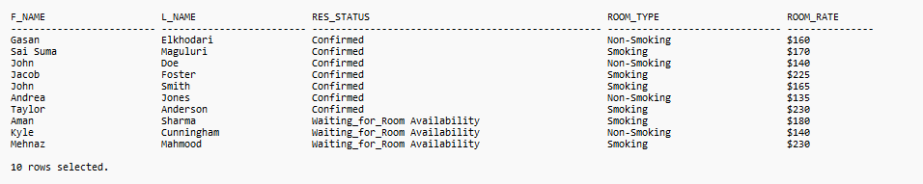Q6.

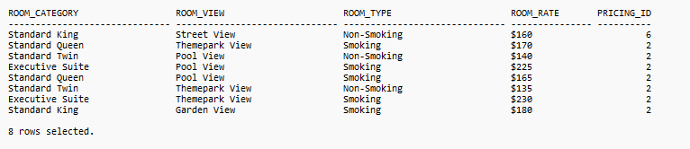Q7.

Q8.

ROOM_CATEGORY ROOM_VIEW ROOM_TYPE BREAK ROOM_RATE

|  |  |  |  |  |
| --- | --- | --- | --- | --- |
| Standard Twin | Themepark View | Non-Smoking | No | $135 |
| Standard Queen | Themepark View | Smoking | Yes | $170 |
| Executive Suite | Themepark View | Smoking | Yes | $230 |
| Q9. |  |  |  |  |



|  |  |
| --- | --- |
| Q10. L_NAME | LENGTH(L_NAME) |
| Elkhodari | 9 |
| Maguluri | 8 |
| Doe | 3 |
| Foster | 6 |
| Smith | 5 |
| Jones | 5 |
| Anderson | 8 |
| Sharma | 6 |
| Cunningham | 10 |
| Mahmood | 7 |
| 10 rows selected. |  |

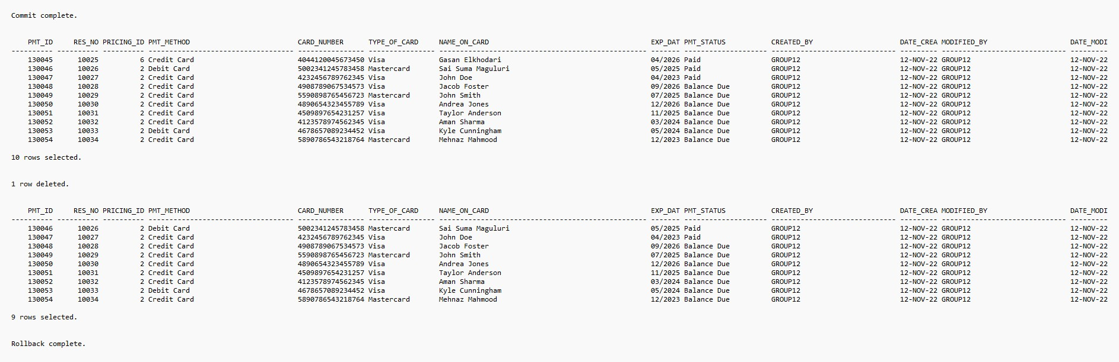Q11.

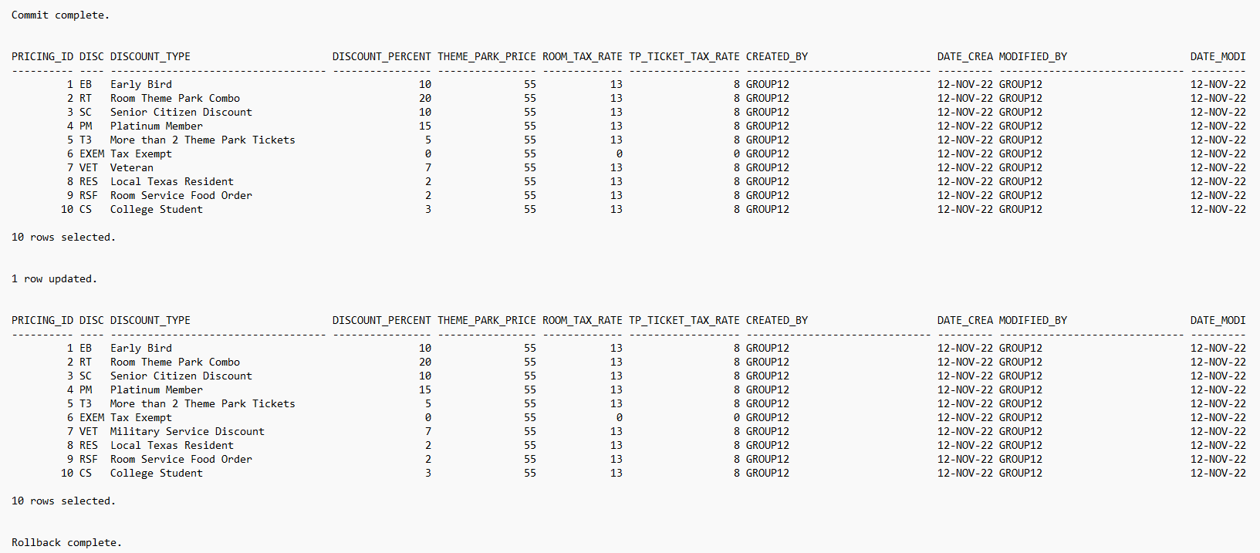Q12.

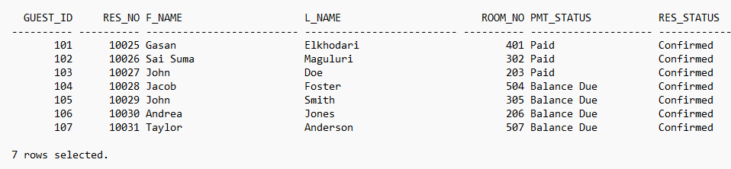Q13.

Q14.

ROOM_NO F_NAME L_NAME ROOM_RATE PMT_STATUS

|  |  |  |  |
| --- | --- | --- | --- |
| 408 Aman | Sharma | $180 | Balance Due |
| 504 Jacob | Foster | $225 | Balance Due |
| 507 Taylor | Anderson | $230 | Balance Due |
| 510 Mehnaz | Mahmood | $230 | Balance Due |

Q15.

ROOM_CATEGORY NUM_OCCURRENCES

Executive Suite 3

Standard Twin 3

Q16.

Q17.

GUEST_ID F_NAME L_NAME NO_OF_GUESTS NO_OF_TP_TICKETS PLA

102 Sai Suma Maguluri 5 5 Yes

1. Aman Sharma 4 3 Yes
2. Kyle Cunningham 3 3 Yes

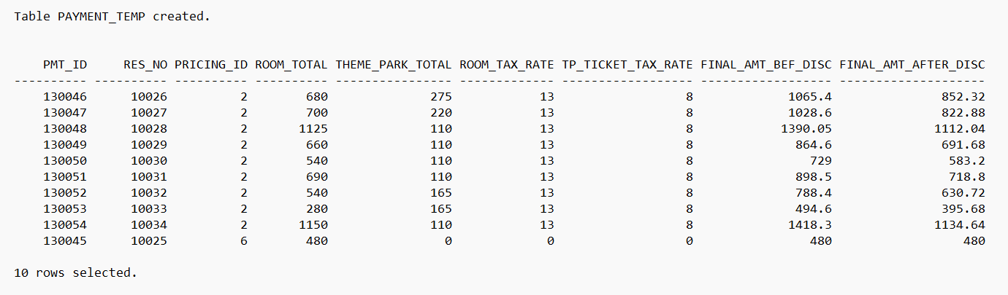Q18.

Q19.

RES_NO F_NAME L_NAME DISC ROOM_RATE ROOM_TOTAL

10025 Gasan Elkhodari EXEM $160 480

Q20.

Table PAYMENT_TEMP1 created.

PLA COUNT_OF_CUSTOMERS_WHO_SPEND_ABOVE_AVERAGE

Yes 2

No 2